

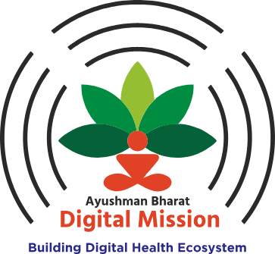
Ayushman Bharat Digital Mission
National Healthcare Provider Registry

National Healthcare Provider Registry
User Manual
Healthcare Professional Profile
(Version – 0.1)
Helpdesk - 1800-11-4477
Visit us at - https://nhpr.abdm.gov.in/login

March 2024
Contents

- Introduction
- Registration Process
- As a Healthcare Professional
- Tabs in the left section (after verification)
- Healthcare Professional Profile

INTRODUCTION

National Healthcare Provider Registry (NHPR) is a comprehensive repository of registered and verified Healthcare Professionals including doctors (Modern Medicine, Dentistry, Ayurveda, Siddha, Sowa-rigpa, Homoeopathy and Unani), nurses (Registered Auxiliary Nurse Midwife (RANM), Registered Nurse and Registered Midwife (RNRM), Registered Lady Health Visitor and Registered Nurse), and the Facilities (hospitals, clinics, diagnostic laboratories and imaging centers, pharmacies, blood banks, etc.) of both government and private sector across India. The Ayushman Bharat Digital Mission (ABDM) empowers the NHPR to onboard the healthcare professionals and the facilities onto India’s digital health ecosystem.

Overview
Healthcare professionals and Facilities who enrolls into the NHPR are digitally connected to a host of interoperable, digitally enabled services for dispensation of healthcare activities and service delivery.

Caution up and Warnings
Processes have been designed to ensure that only verified healthcare professionals and facilities are onboarded after approval from respective authorized bodies.

Set- Consideration
National Healthcare Provider Registry (NHPR) follows a minimalistic approach to data collection and only seeks information which is necessary to verify the identity and credentials of a healthcare professional. This includes demographic, contact, registration, academic, and place of work details.

User access Consideration
All starred fields are mandatory. They allow us to cross-check the information provided. It is advisable to include the academic qualifications which have been registered with the respective council/governing body.

2. REGISTRATION PROCESS

a) As a Healthcare Professional

Step 1: Go to the portal https://nhpr.abdm.gov.in/home to register in the National Healthcare Providers Registry Portal.
Step 2: Click on the ‘Login/ Registration’ button on the right upper side of the screen
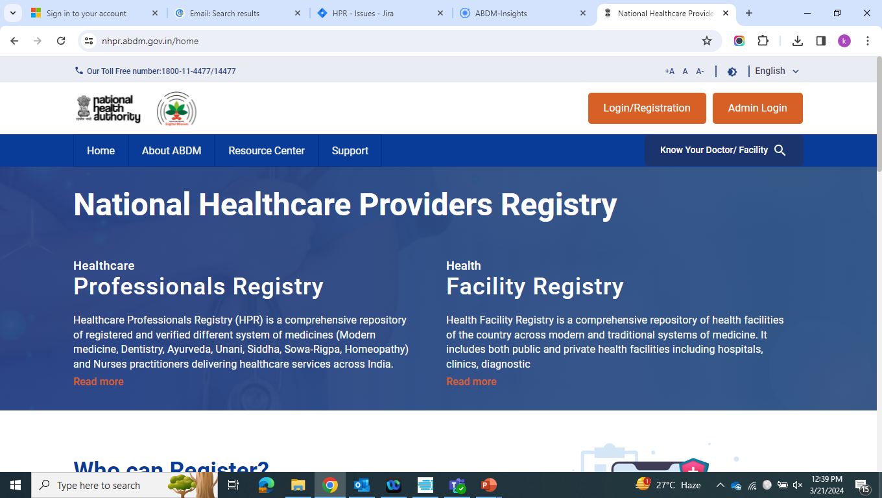
Step 3: Click on the ‘Register Here’ option available at the bottom of the page.
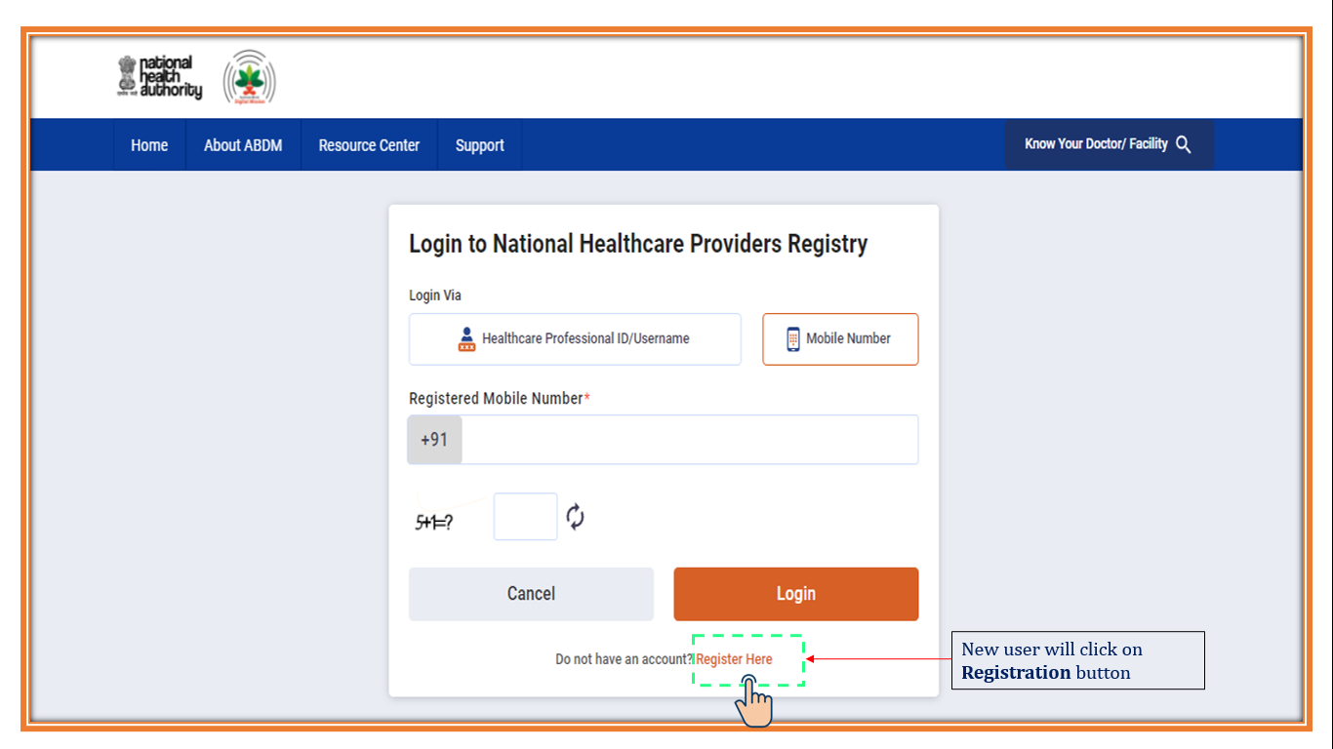
Step 4: Then the next page appears. There are the following two options to generate the Healthcare Professional ID –
- Via Aadhaar
- Via Driving License

Here we will go step by step on how to generate the Healthcare Professional ID via Aadhaar-

Step 5: The user has to click on the ‘Aadhaar’ option to generate the Healthcare Professional ID.
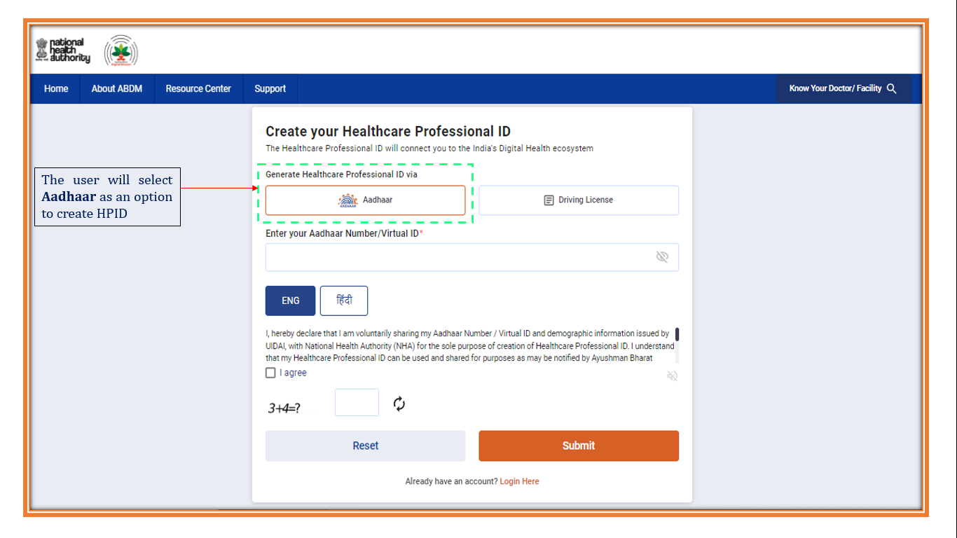

Step 6: After entering the Aadhaar number, the user has to click on ‘I agree’ option and provide his consent. Then the captcha has to be entered.
After giving the consent and entering the captcha, the user has to click on the ‘Submit’ button.

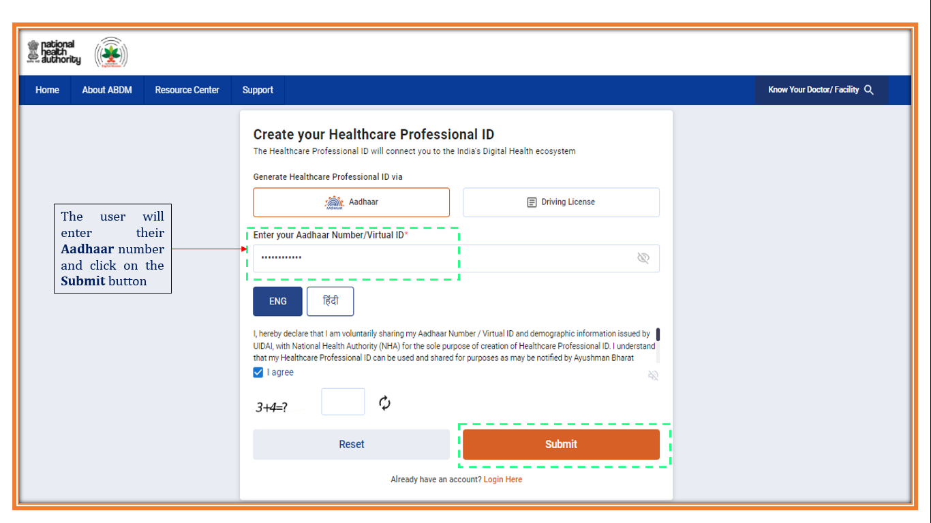

Step 7: After clicking on the ‘Submit’ button, the user will get an OTP on the mobile number linked with the Aadhaar.
Then the user will enter the OTP and again click on the ‘Submit’ button for proceeding.

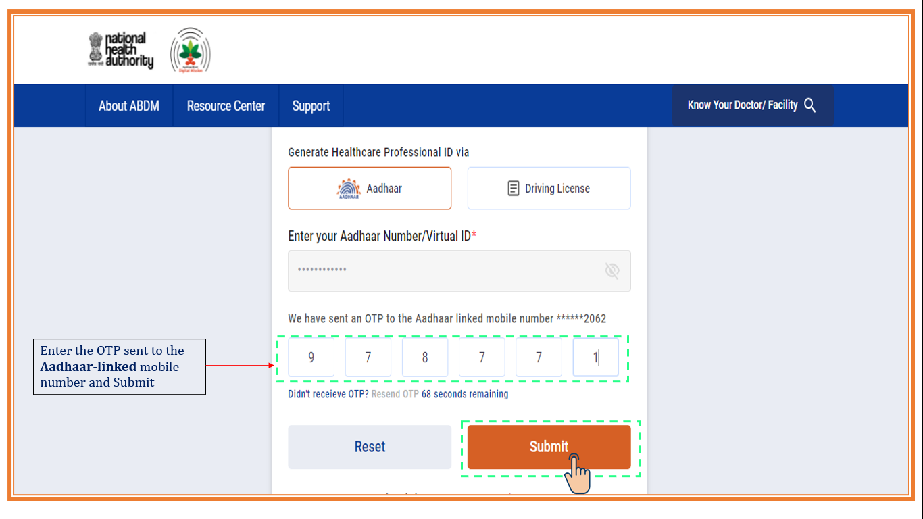

The details from the Aadhaar get captured and the profile of the user appears to proceed further for entering the details to register.

Step 8: The registration form appears where the user will enter the following details-
- Mobile number
- Email ID
Then the user will click on the ‘Verify’ option to verify both- the mobile number and Email ID. Email id verification is optional.
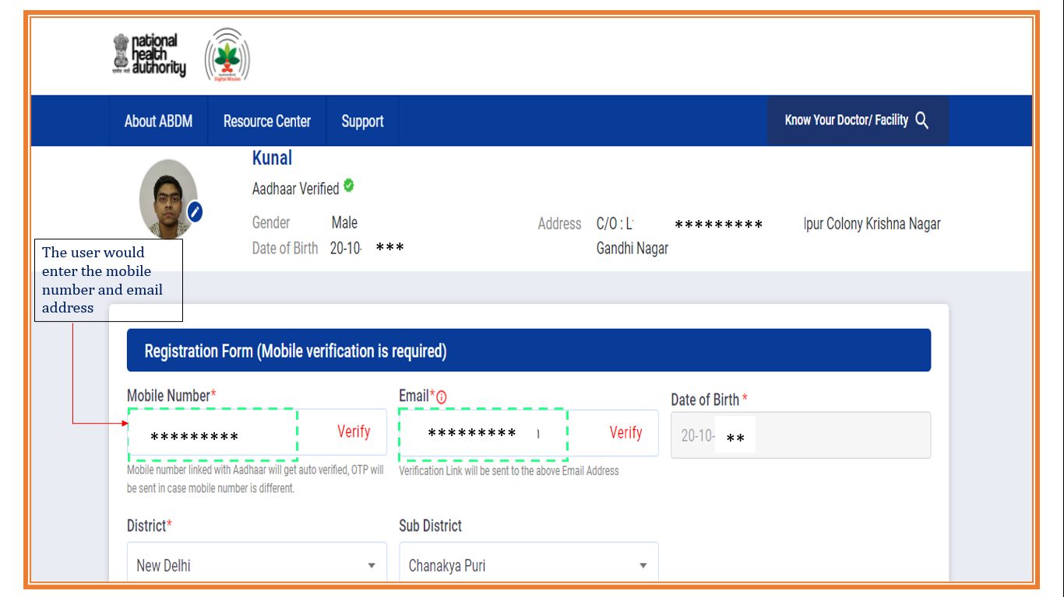

a) If the mobile number entered is verified/registered on Aadhaar the pop-up would appear.
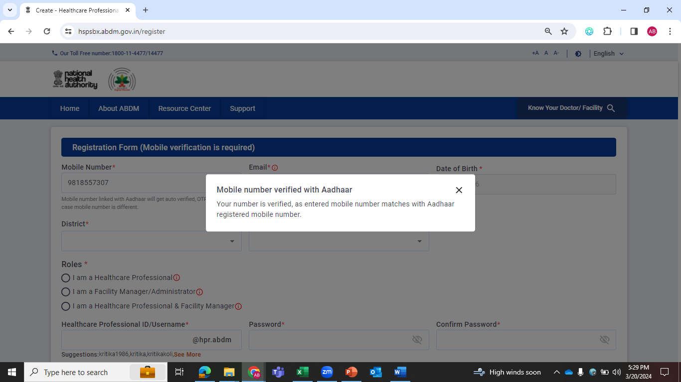

b) If the mobile number entered is different from verified/registered in Aadhaar, then enter the OTP sent to the entered mobile number.

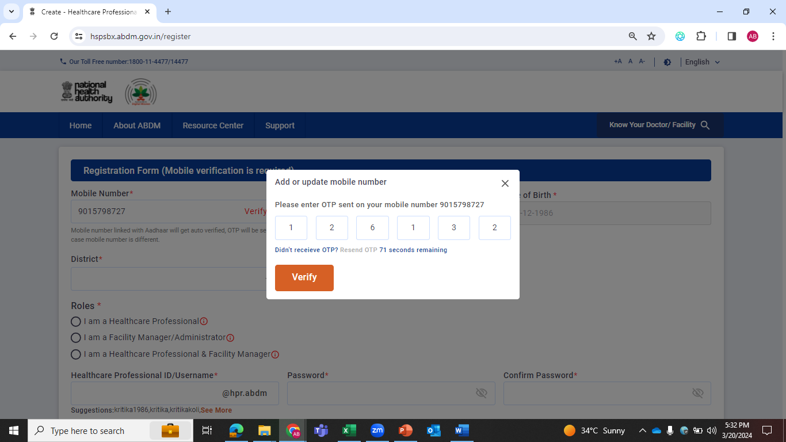

Step 9: District and Sub-district are fetched from the information provided. If in case is not available enter the details manually.
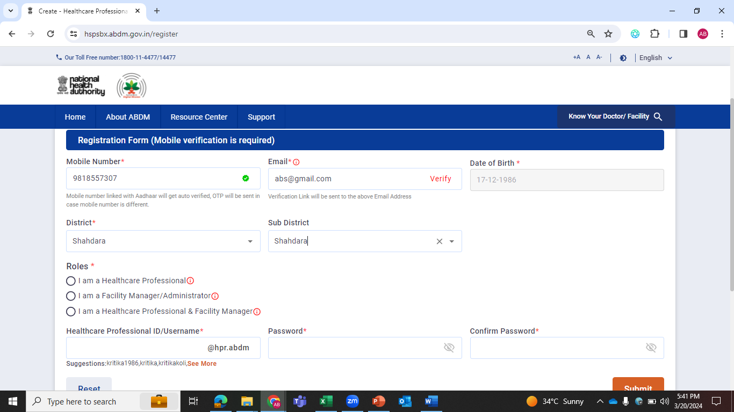

Step 10: Select the role- ‘I am a Healthcare Professional’ from the following options-
- I am a Healthcare professional: This option is for Doctor/ Nurse who are only professional and not a facility Manager
- I am a Facility Manager/ Administration: This option is for Facility Manager who are not Healthcare professional
- I am Healthcare Professional and Facility Manager: Professionals who are Doctor/Nurses and facility manager
Enter the details of the category and sub-category.

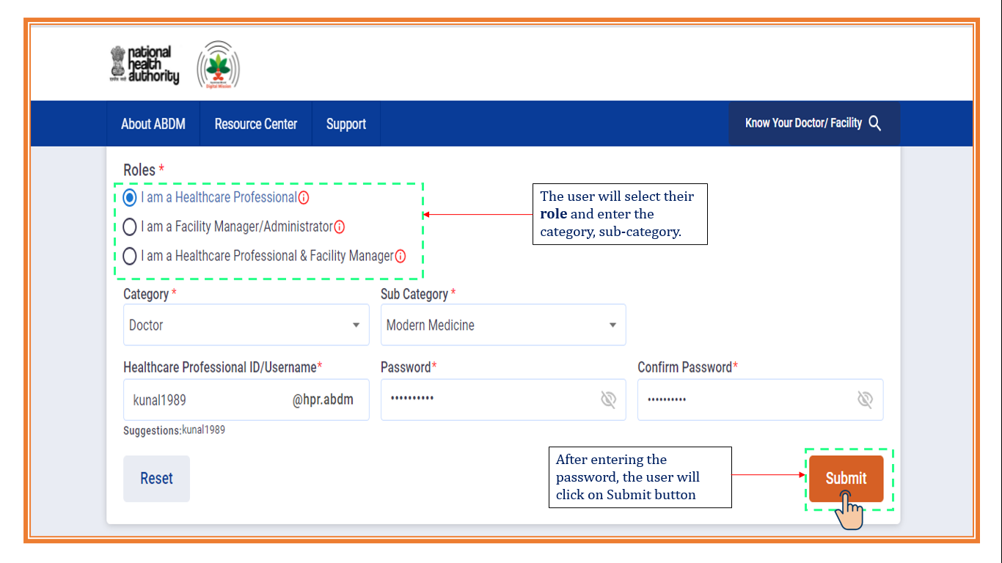

Enter the Healthcare Professional ID/username. The user can also select the username from the suggestion provided below the option.
Enter the Password and Confirm the password and click on ‘Submit’ button.

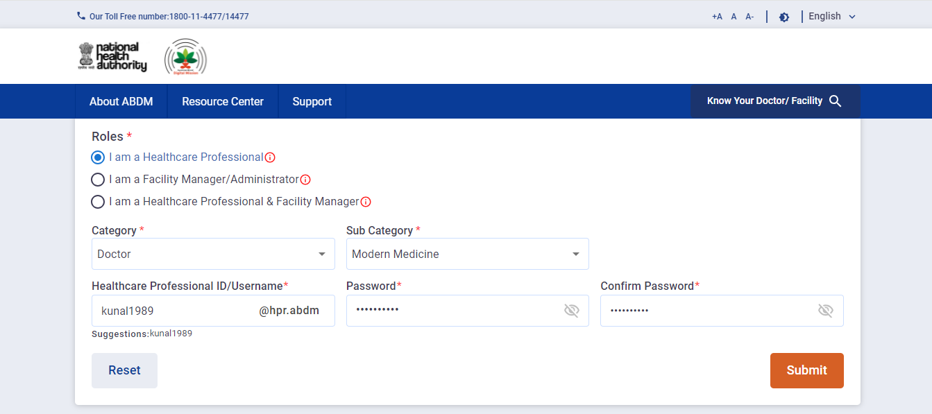

Password having policy like-Should be 8 characters, 1 character should be Capital, 1 should be small, 1 special symbol and 1 numeric digit.

Step 11: There are 4 steps to register the HPR profile:
- Personal Details
- Qualifications and Registration Details
- Work Details
- Preview Profile
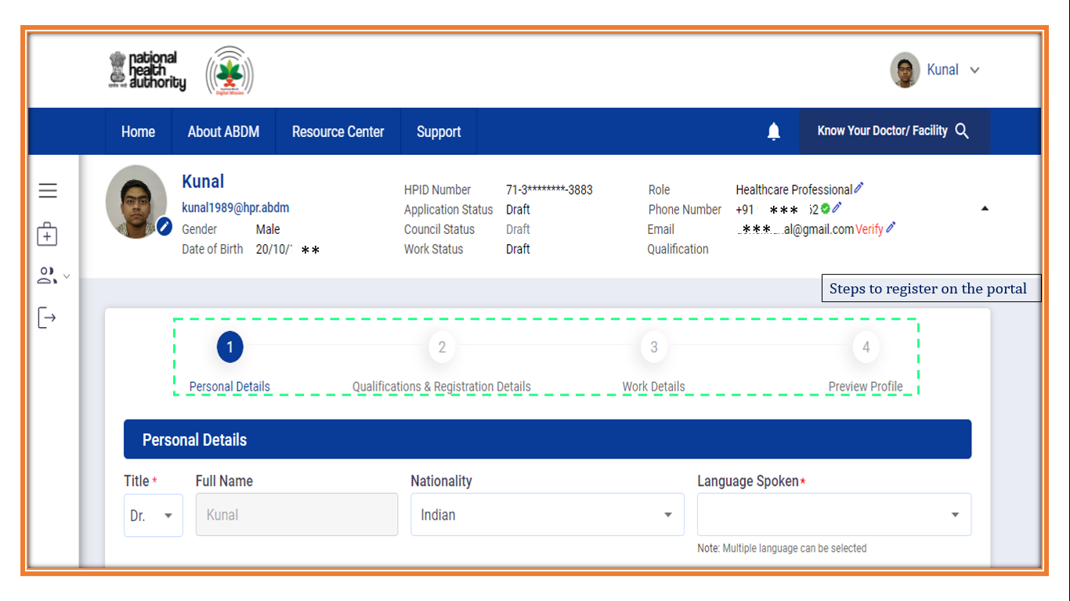

Personal Details-
The details like name, address, etc. are fetched automatically.

Step 12: Enter the languages spoken. The user can select multiple languages.

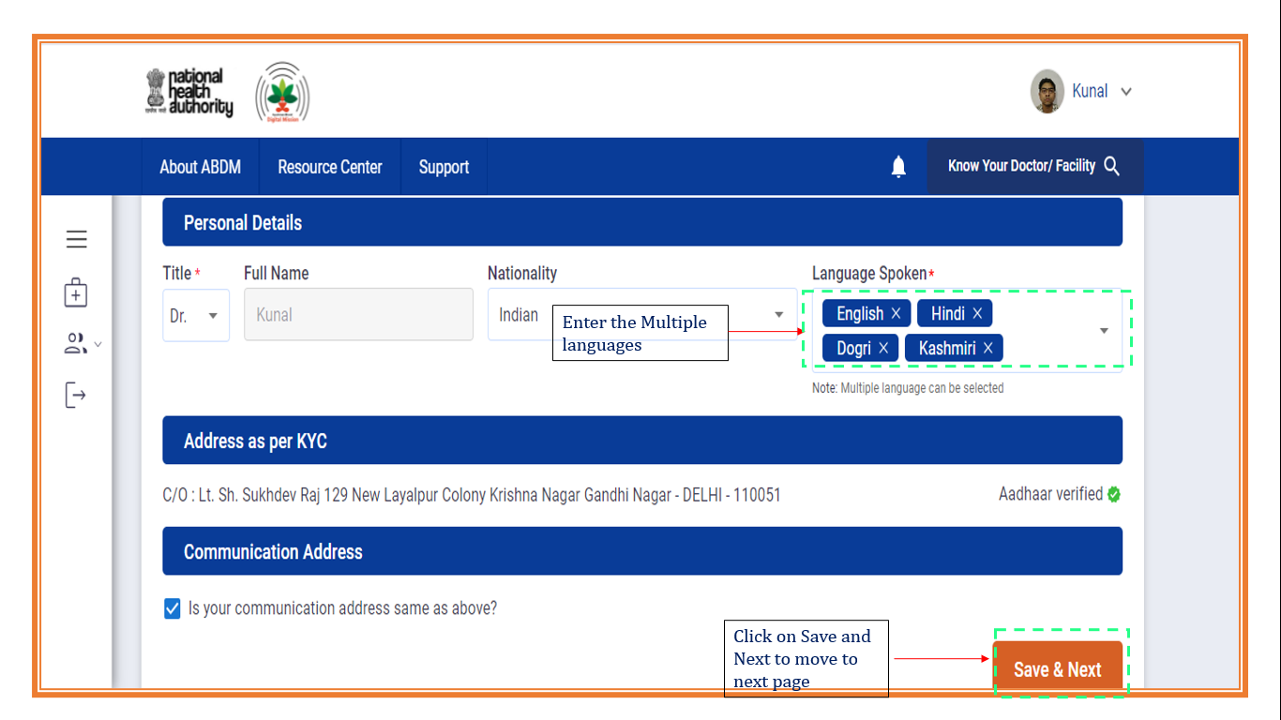

Step 13: If the communication address is different from the KYC, then uncheck box and enter the details of communication address and click on ‘Save & Next’ button to proceed further to the next section.
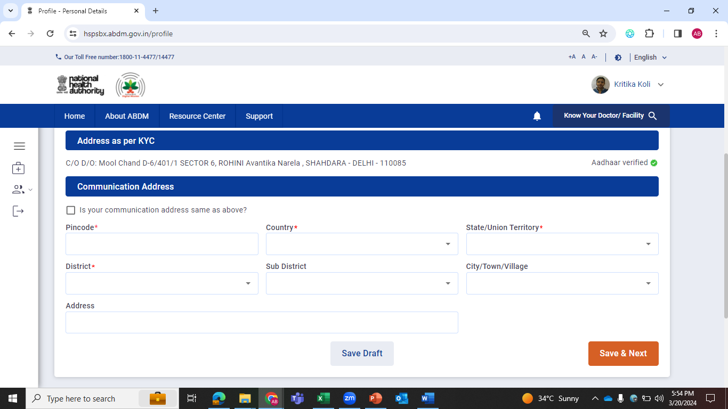

Qualifications and Registration Details-

Step 14: In the registration details; the user will enter the registration number, date and council of registration.
After entering the registration details, the user will attach the registration certificate document. The user can also upload the documents from Digi Locker, as there is an option available at the right side ‘Pull from Digi Locker’.
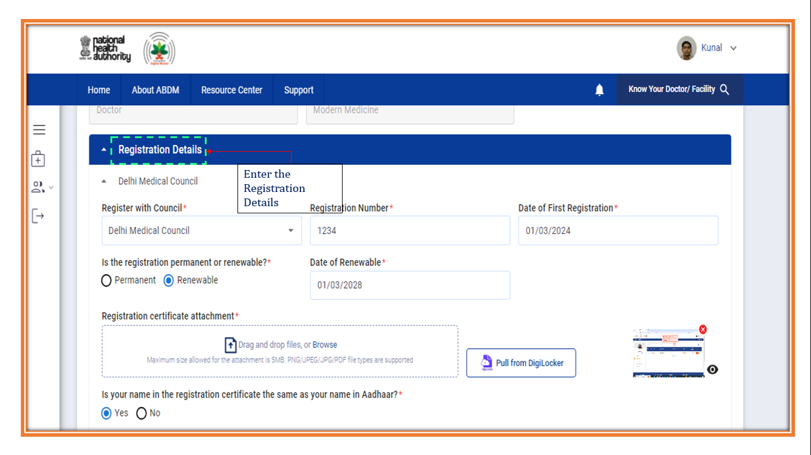
Step 15: Then the user will enter qualification details and upload the degree/diploma certificate document.

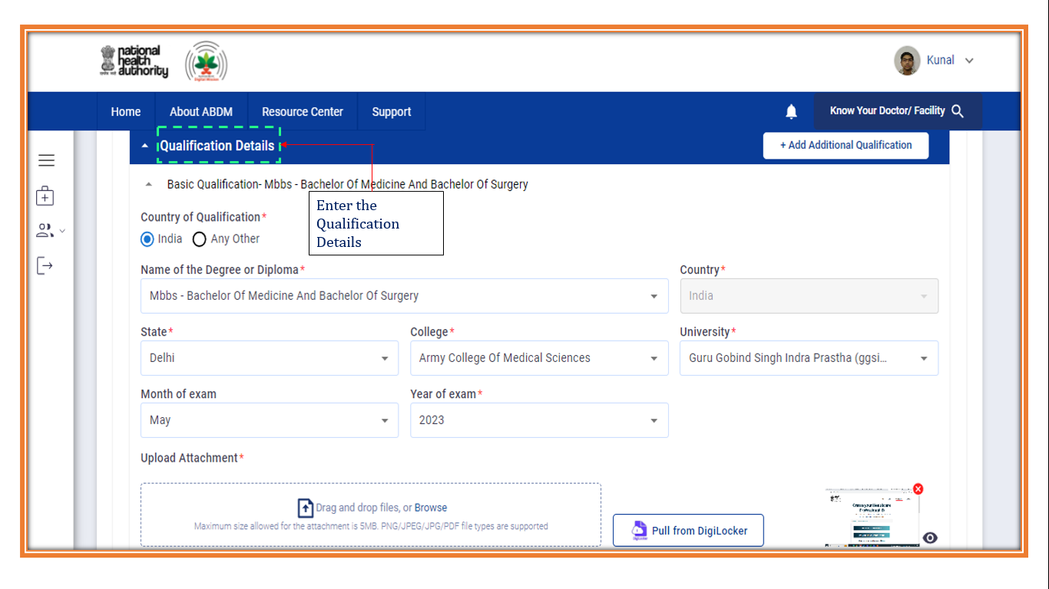
Step 16: If in case the name of the user is different in Aadhaar and degree/ registration, then attach the relevant documents like name change affidavit, etc. and click on ‘Save and Next’ button.
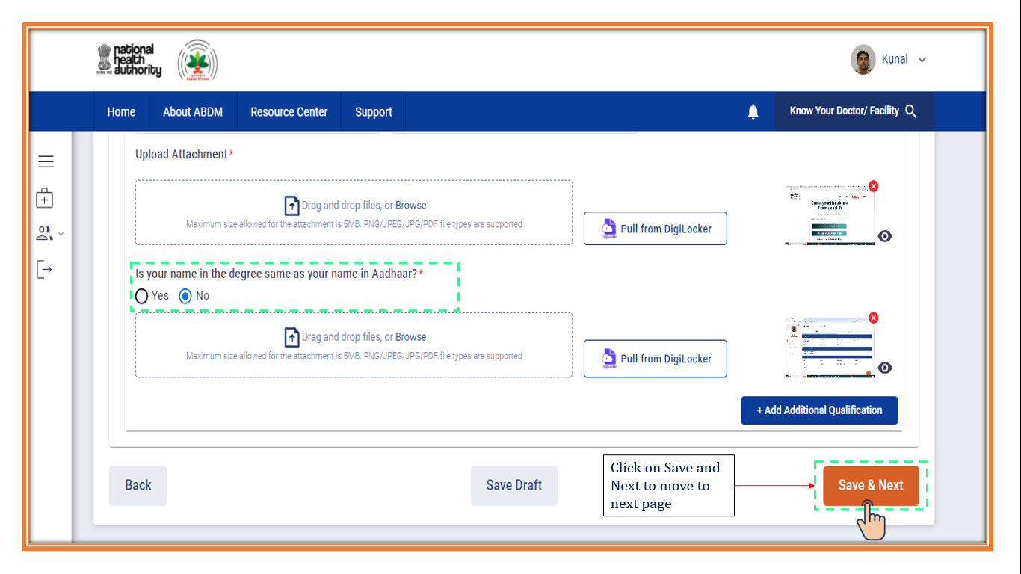

Work Details-

Step 17: In this section, the user will enter the work details, work status, and the place of work. He/ She can select multiple options in Nature of work.
After filling all the details for place of work, the user will click on ‘Save and Next’ button.
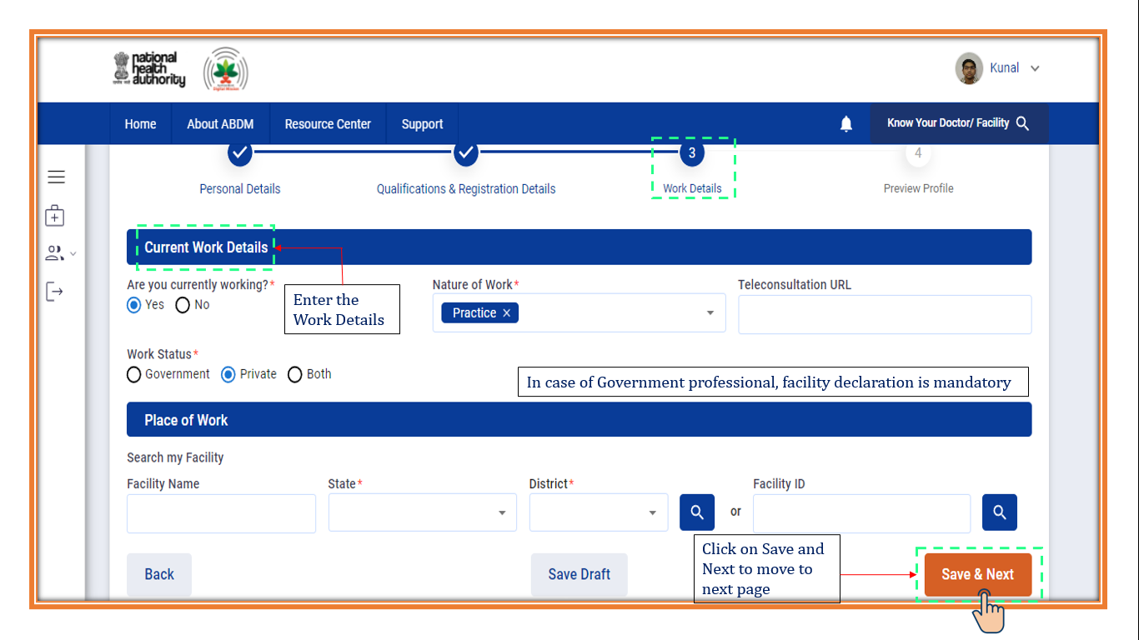
If the user has selected government or both in Work status, then she/ he have to mandatorily attach the document for the proof of working in the government facility like work order, appointment letter, etc.

Step 18: Place of work is mandatory for the government professionals and are optional in case of private professionals.
The user can search the Facility through the Facility name, State, District or through Facility ID.
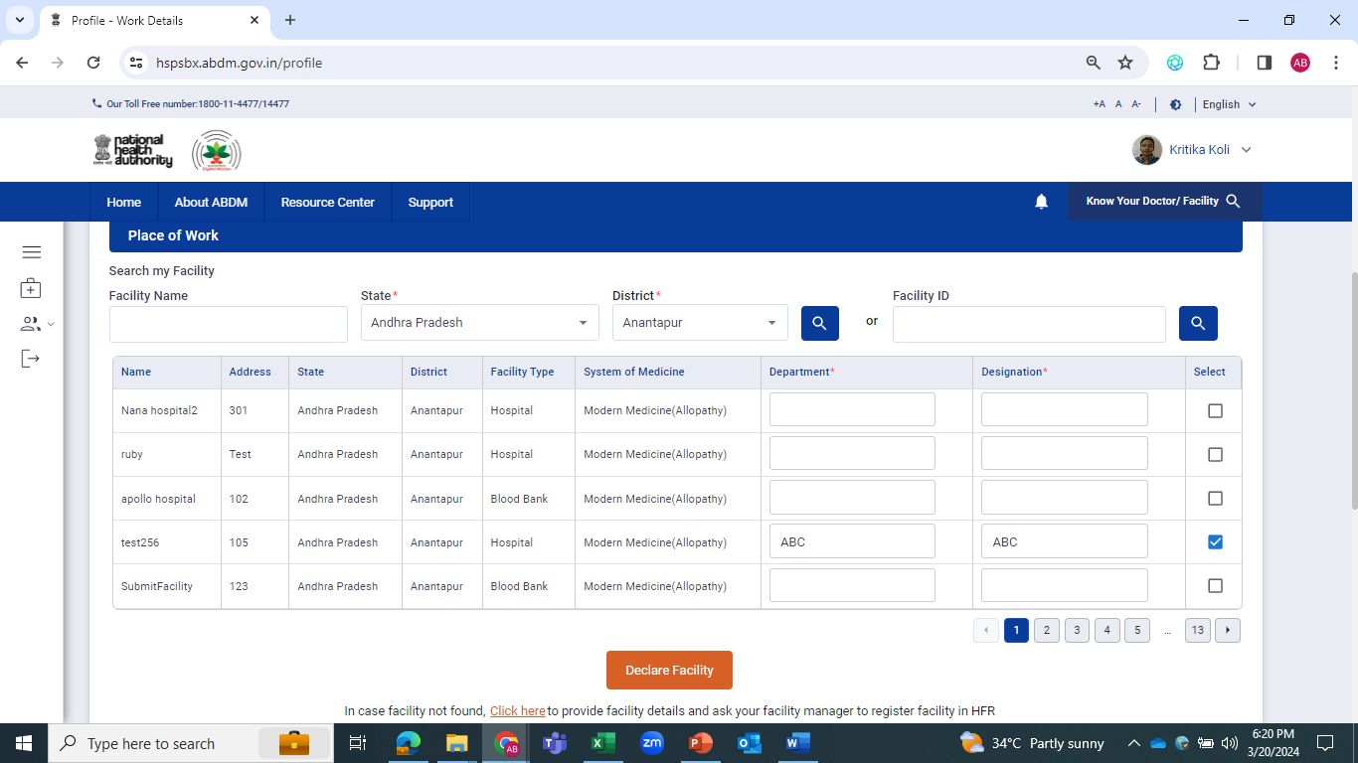
Click on ‘Declare Facility’ button after filling up the details and click on check box on the right side.

If the facility is not available in the list provided, the user can go to ‘Click Here’ button, present below the Declare Facility and enter the details.

Preview Profile-
Step 19: To preview the profile, go to “Click here”
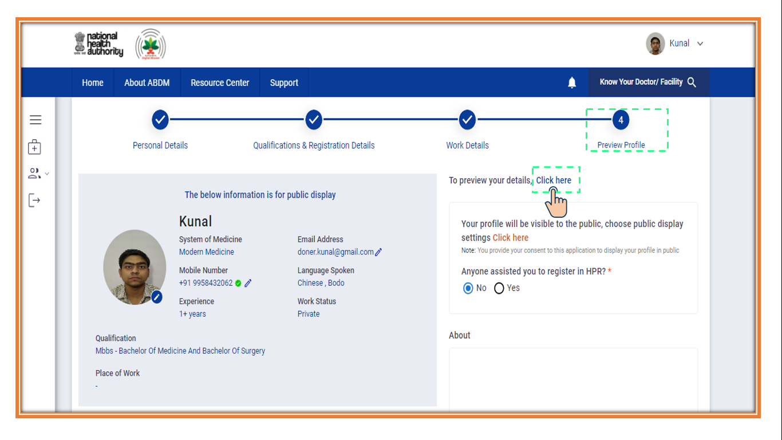
Step 20: The user can cross-verify all the details that have been entered before the final submission.
In case the user wants to update profile, click on the pen icon on the top right side of the pop-up.
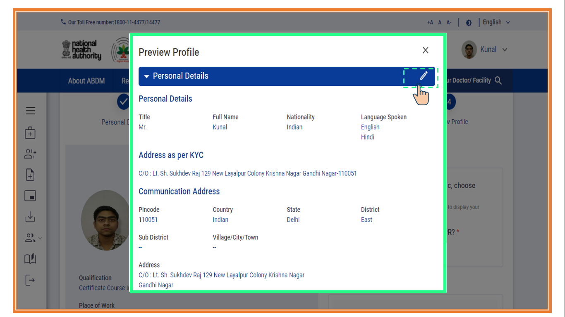
Step 21: Tick the check box for final declaration and click on ‘E-sign and Submit’ button.
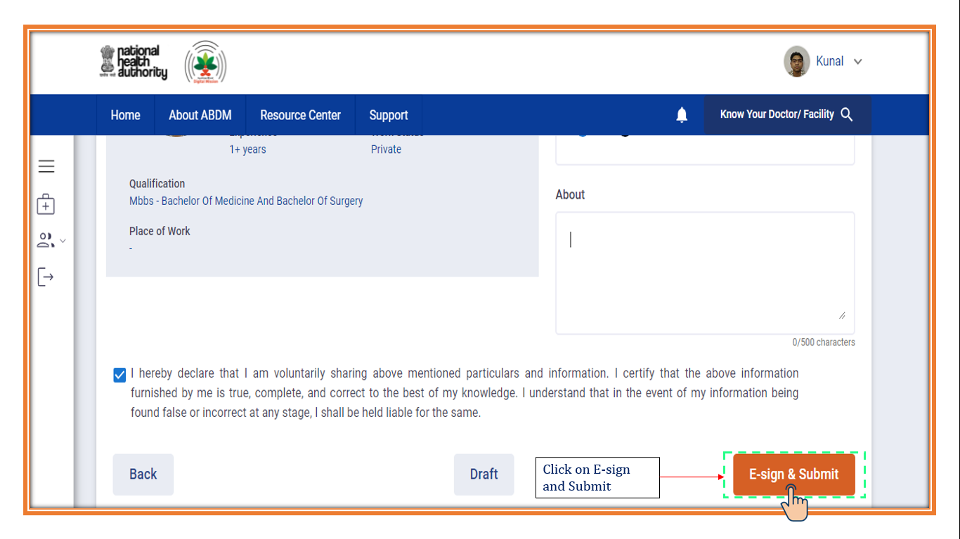
Step 22: A new portal will appear; the user will enter his/her Aadhaar number and click on ‘Get OTP’ option.
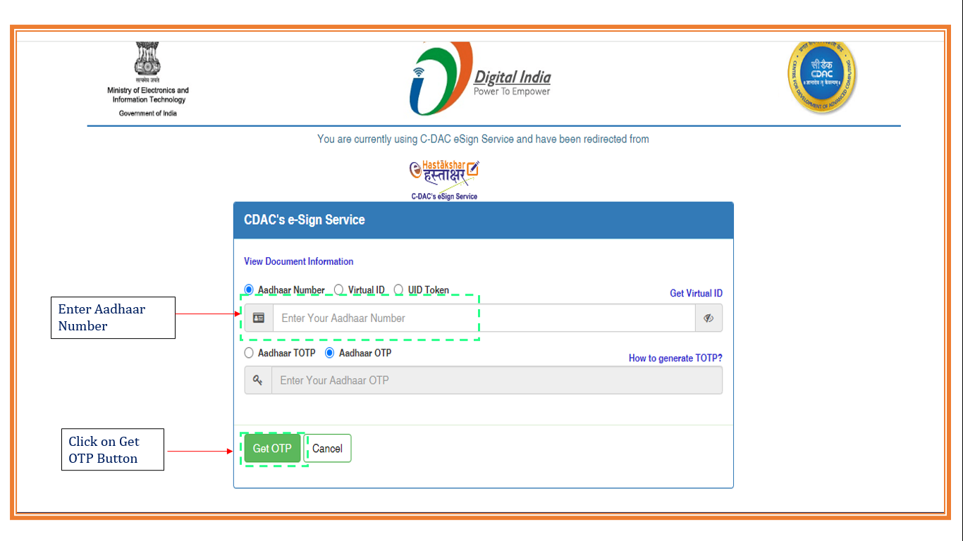

Step 23: After entering the OTP received on Aadhaar registered mobile number; the user will click on the check box and then click on the ‘Submit’ button.
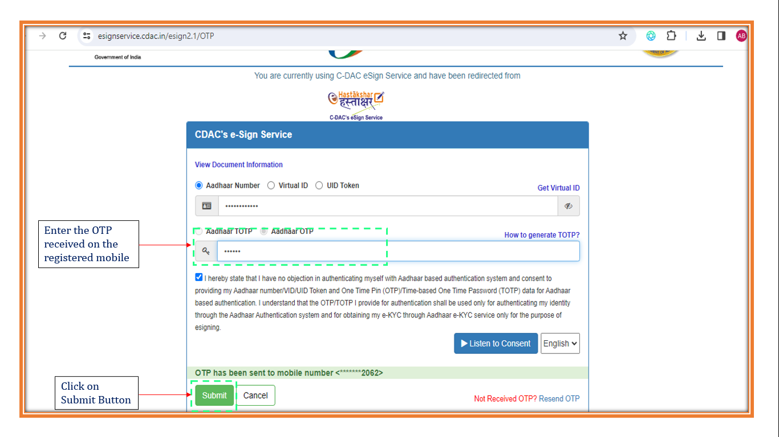

A notification will appear that shows the successful completion of the E-sign. And click on the ‘OK’ button.
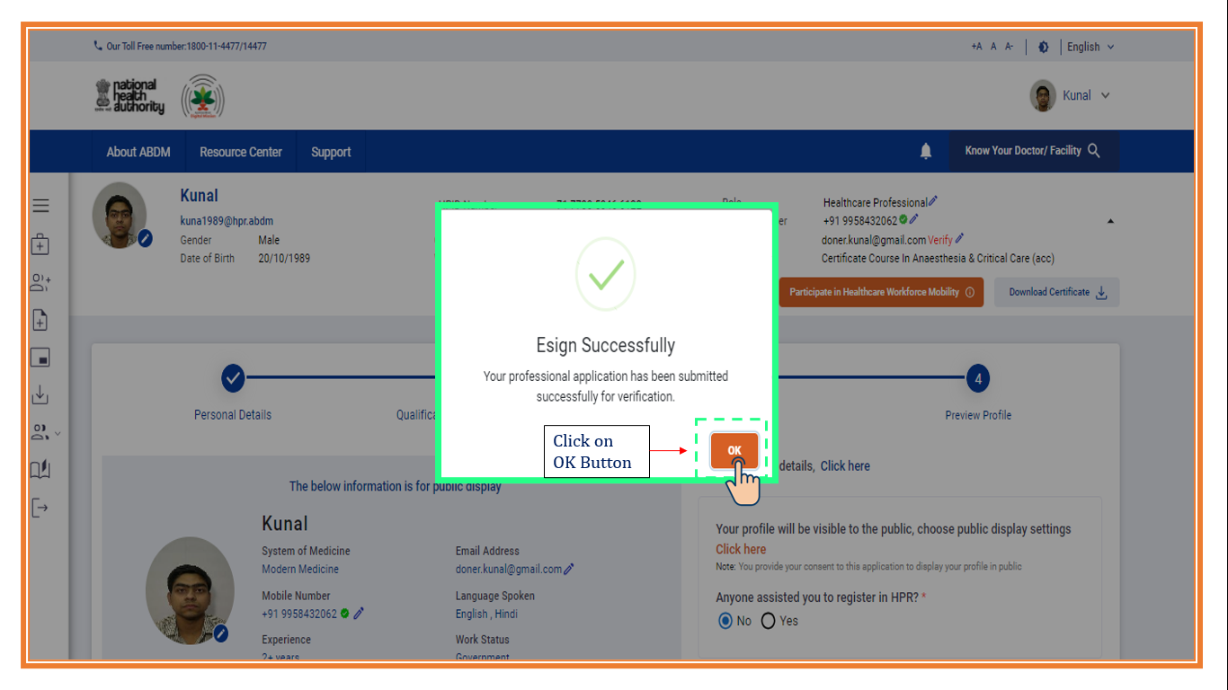

Step 24: A pdf would be generated and downloaded, after successful e-sign and submit of the Application.
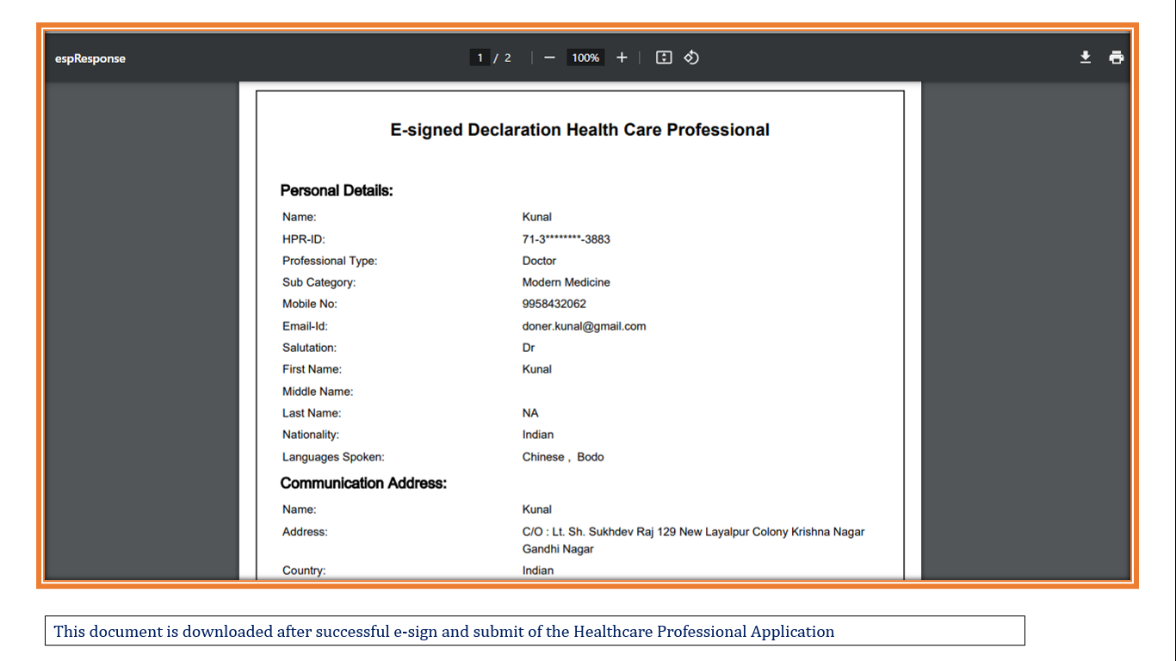

Step 25: The profile
- Edit Profile
The profile can be edited by clicking on the ‘Edit Form’ button. Professional can change the mobile number, email ID and the Role.
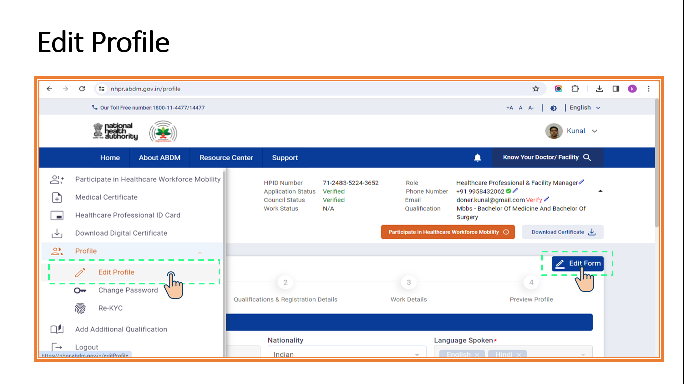
- Change Password
This sub-section allows the user to change his/her profile password. The user can change the password via three options- old password, Aadhaar OTP and mobile OTP.
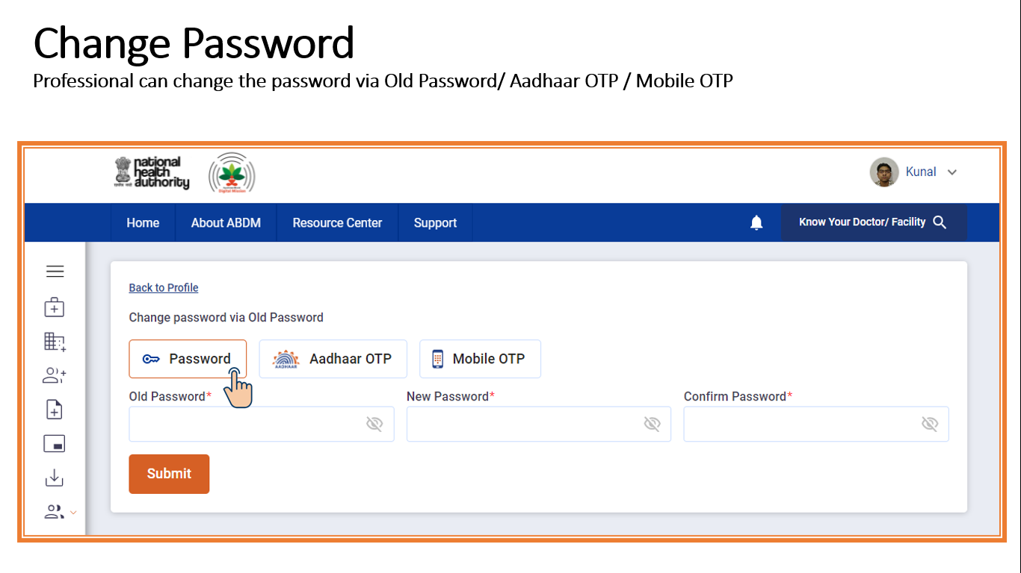
- Re-KYC
This option allows the user to do re-KYC. The user will click on the ‘Re-KYC’ button and the following screen will appear.

An OTP will be sent to the Aadhaar linked mobile number of the user and the user will have to submit the 6-digit OTP to proceed further.

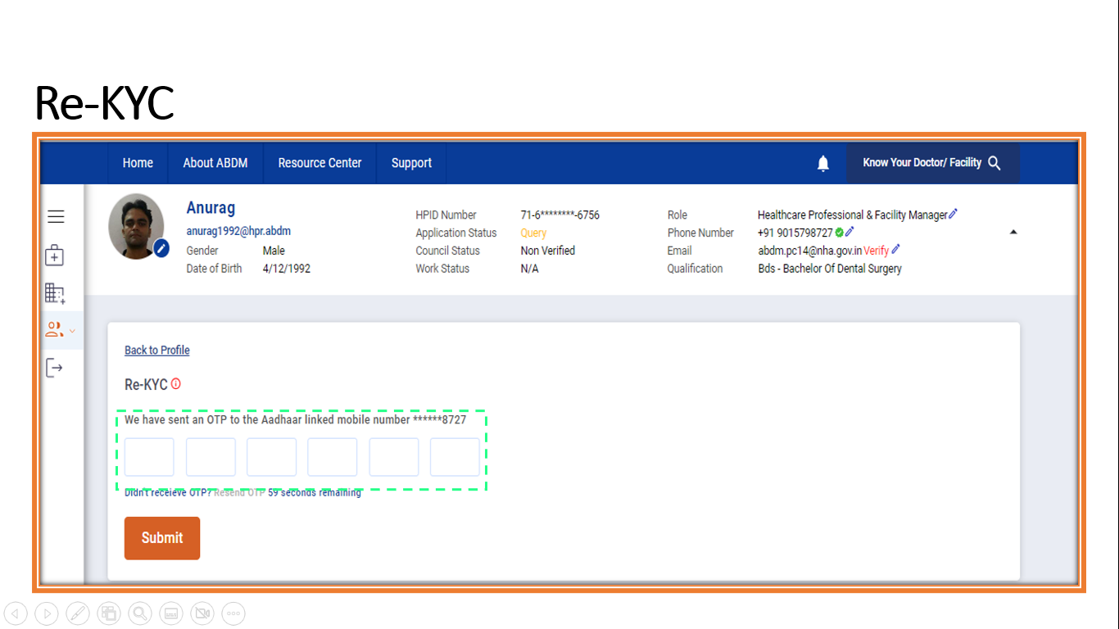

3. Tabs in the left section

Healthcare Professional Registry
Once the Healthcare Professional application of the user is verified by the Council/State, the left menu will get added with a few functionalities like Participate in Healthcare Workforce Mobility, Medical Certificate, Download Digital Certificate and Additional Qualification buttons are visible on the left menu.

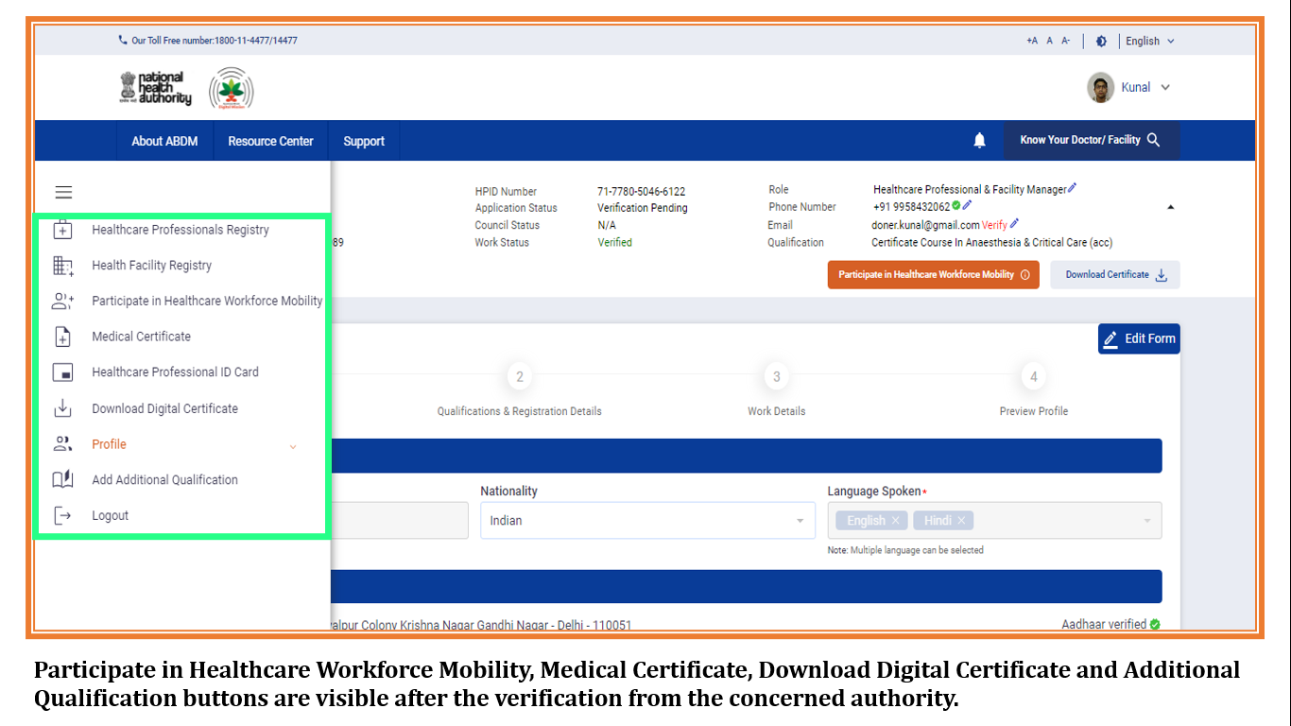

  - Participate in Health Workforce Mobility

This option would be available to the user only after the verification would get completed by the Council/Work verifier. The professionals can also participate in the healthcare workforce mobility by creating their profile through this section.

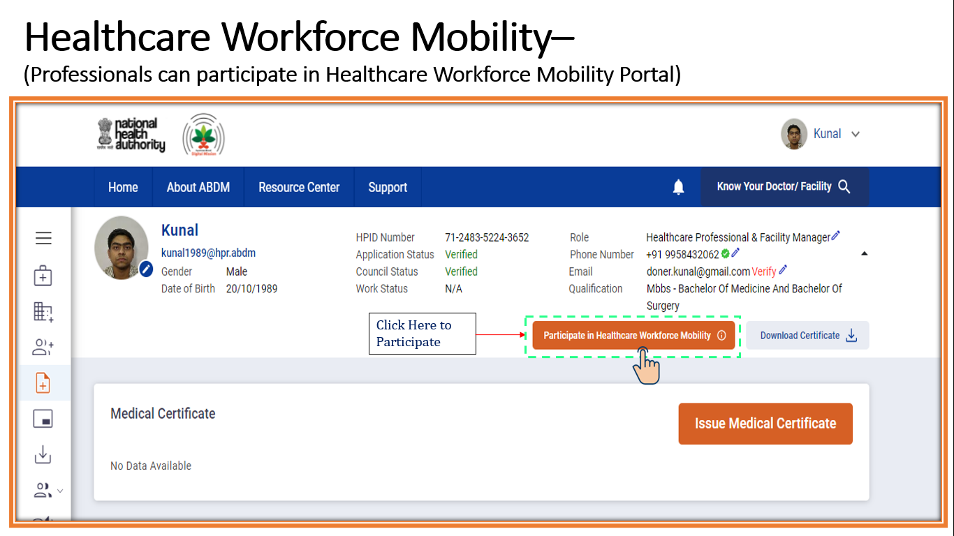
In the ‘Update Healthcare Workforce Mobility Profile’, the user will fill the details of preferred countries he would like to fill along with the qualification details.
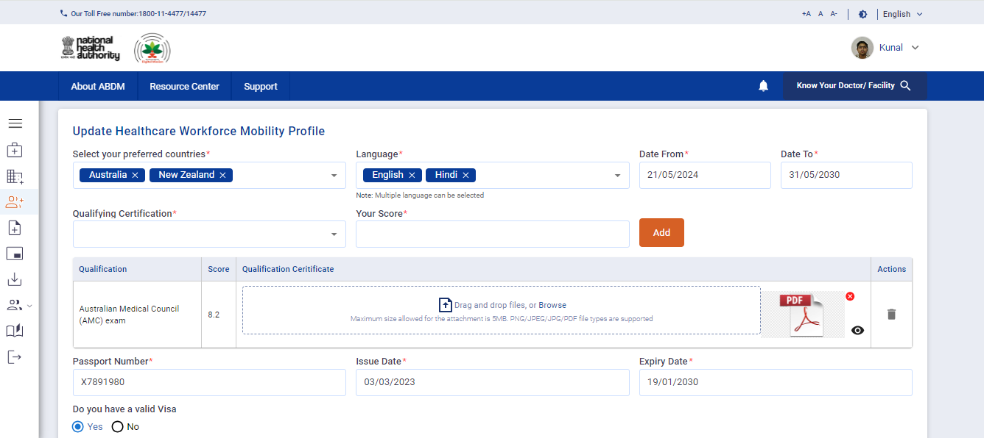
The details about the Passport and Visa are also to be added by the user. There is an option ‘Add Visa’, by clicking on that option, the user can add his/her visa.

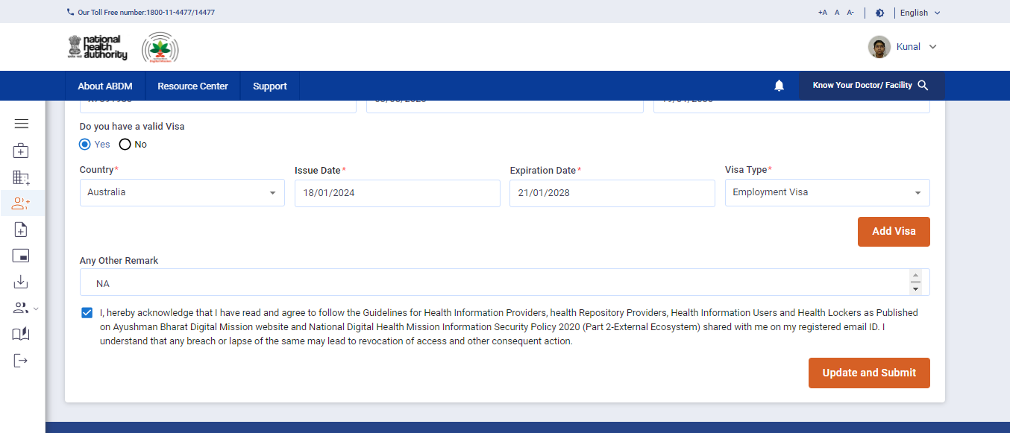
After filling all the details, the user would give consent to proceed further and click on ‘Update and Submit’ option.
The user profile will get created for healthcare workforce mobility.
  - Medical Certificate
This option would be available to the user only after the verification would get completed by the Council/Work verifier. Currently, only modern medicine doctors can issue the certificate.

The user will click on ‘Issue Medical Certificate’ button.
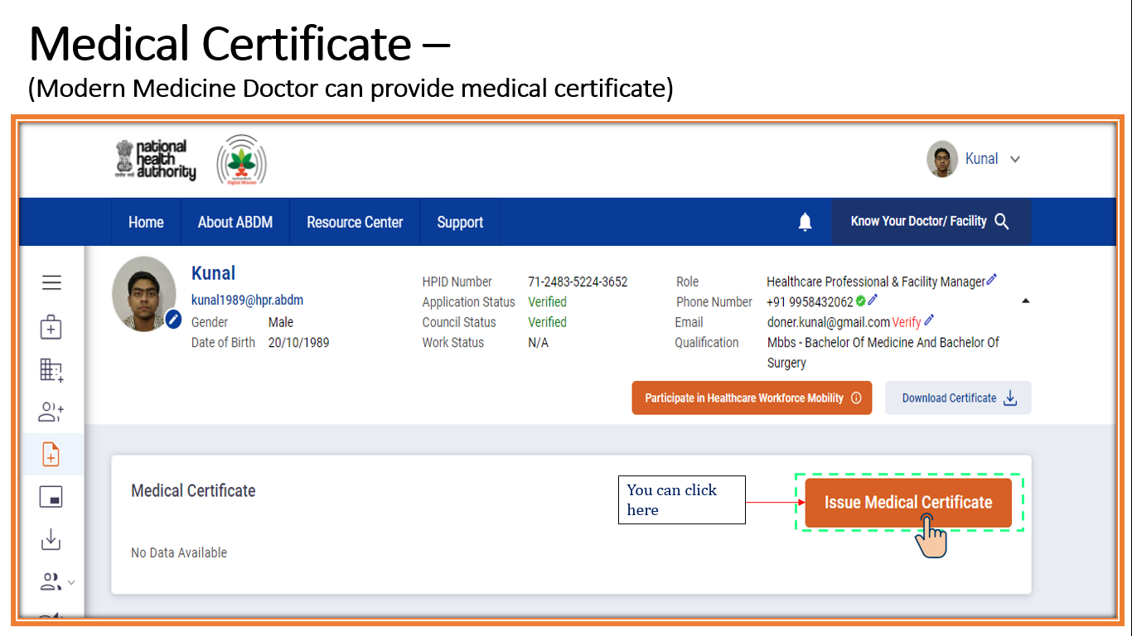

The user will select the medical certificate from the dropdown options.
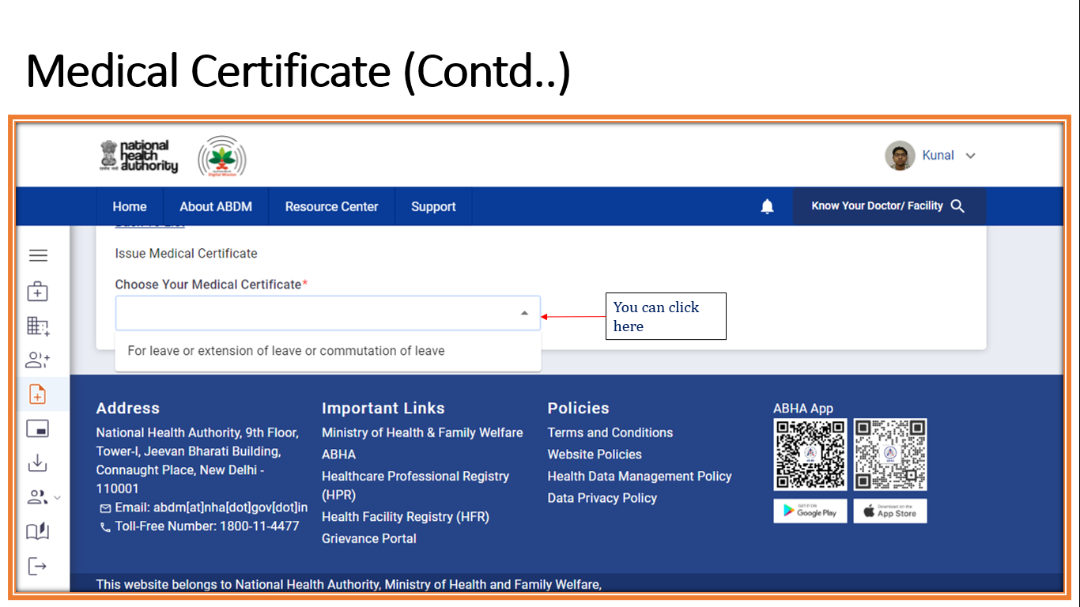

Then the user would enter the details of the patient including the name, disease, days off required by the patient, along with the email ID. And click on ‘Preview’ button.
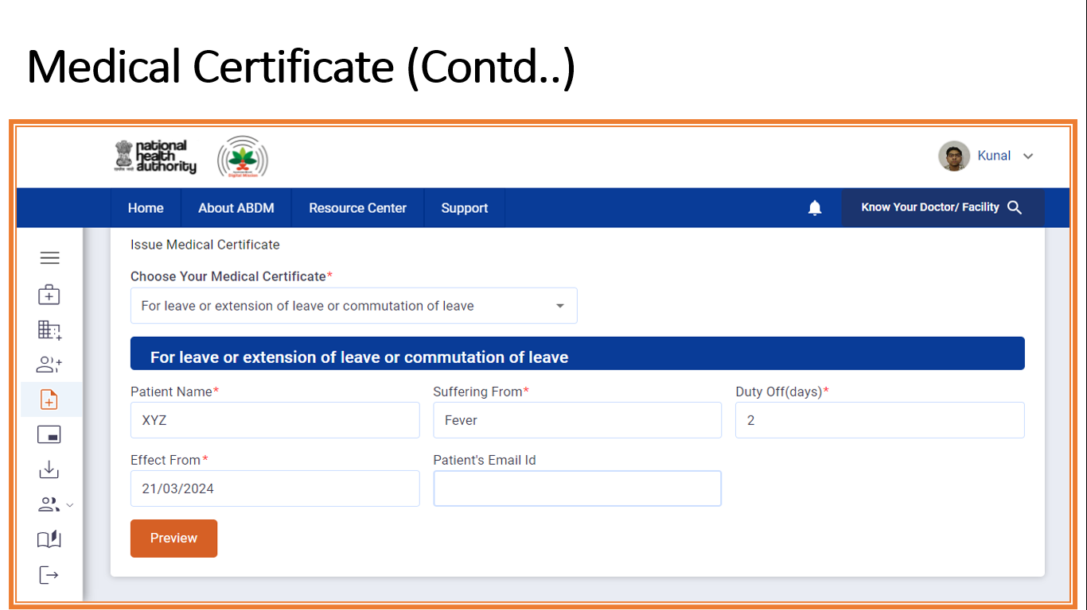
The user can re-check the content of the medical certificate and click on ‘Generate & E- sign’ button at the left bottom of the screen.
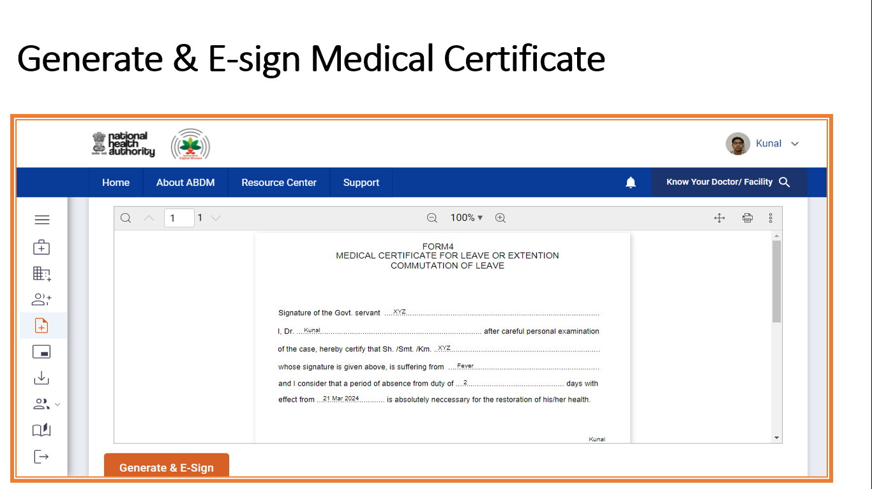
A new portal will appear; the user will enter his/her Aadhaar number and click on ‘Get OTP’ option.

After entering the OTP received on Aadhaar registered mobile number; the user will click on the check box and then click on the ‘Submit’ button.


3.3 Healthcare Professional ID Card
This section gives the option to see the ID card of the professional where he/she can check if the details are correctly mentioned or not. This option would be available to the user only after the verification would get completed by the Council/Work verifier.
The user would Click on the left menu to view the HPR-ID card. To download the card, the user would then click on the ‘Download HPID Card’ from the right upper corner.
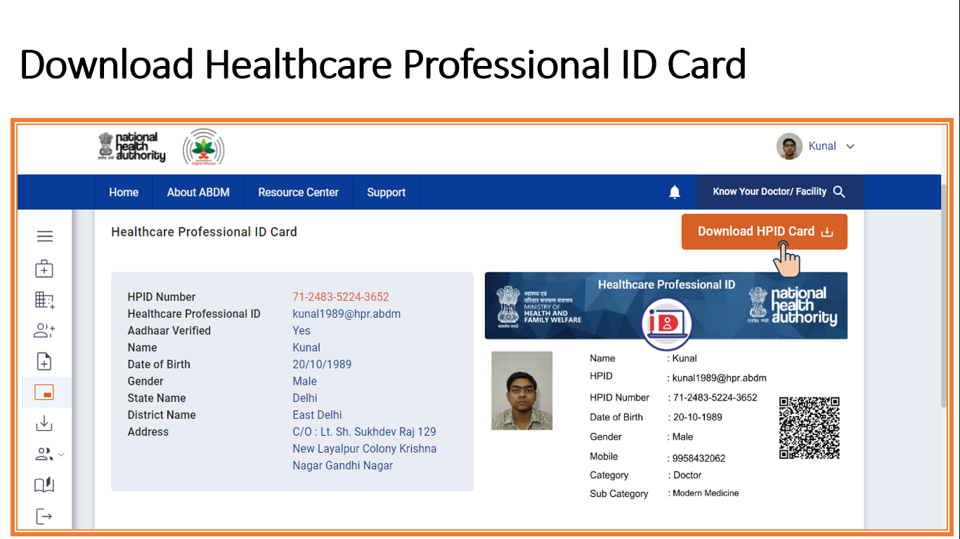
  - Download Digital Certificate
The user can download Digital Certificate by clicking on the ‘Download Digital Certificate’ on the left menu.
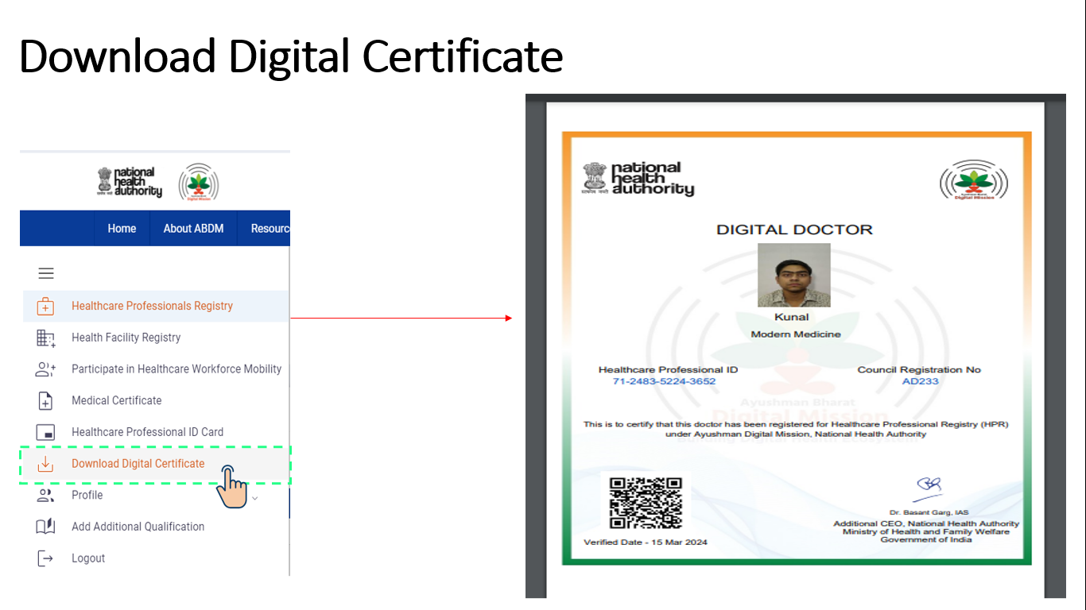
Currently, only doctors of all the system of medicines (Modern Medicine, Dentistry, Ayurveda, Siddha, Sowa-Rigpa, Homoeopathy, Unani) can download the certificate.
  - Add Additional Qualifications
In this section, the user can add and update the additional education qualifications, if required.
For this, the user will click on the ‘Add Additional Qualification’ button on the top right corner of the screen.

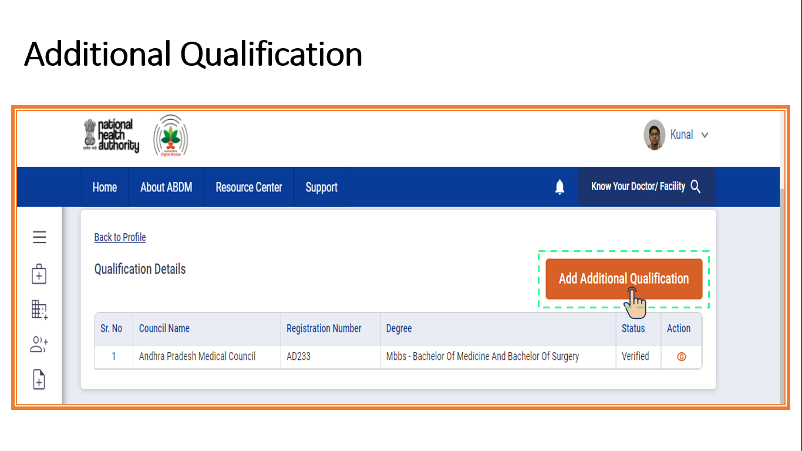
The user will fill the additional qualification details like name of the council, registration number and date of registration.
The user will also upload the Registration certificate document.
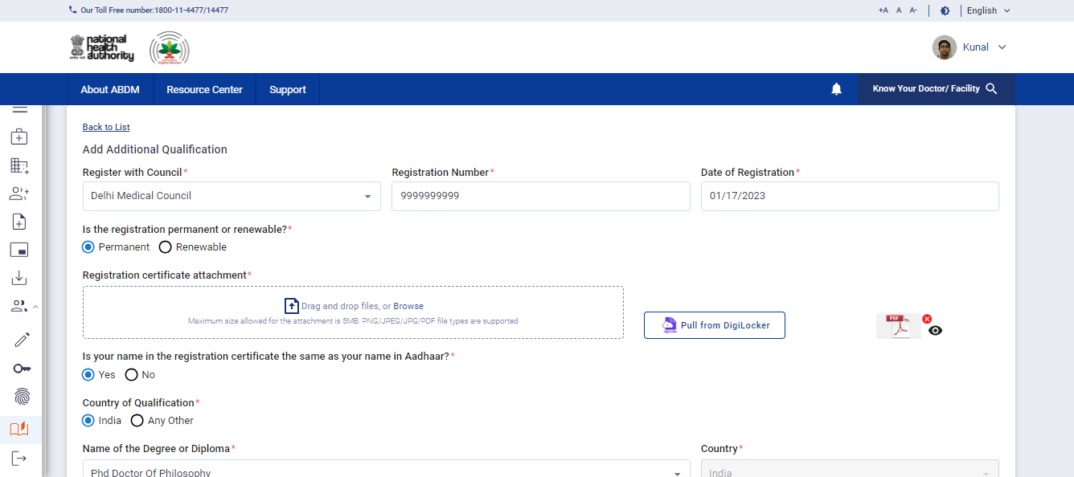
After that, the user will add the name of the degree/diploma and the place from where the qualification has been pursued.
Later, the user will attach the document/certification of the qualification pursued.
After entering all the required details, the user will click on ‘Submit’ button.

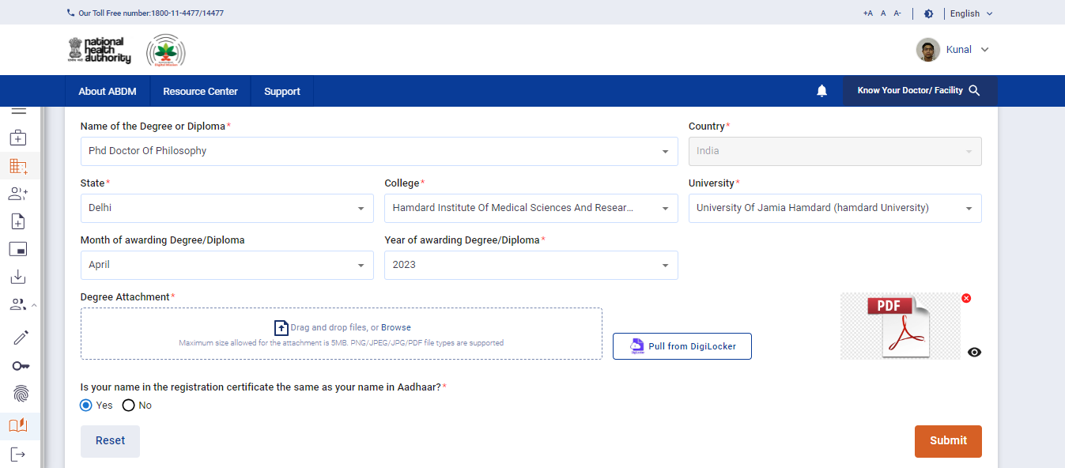

  - Logout
This last option gives the option of logging out from the user profile. The user can click on the ‘Logout’ button and log out from the profile.

